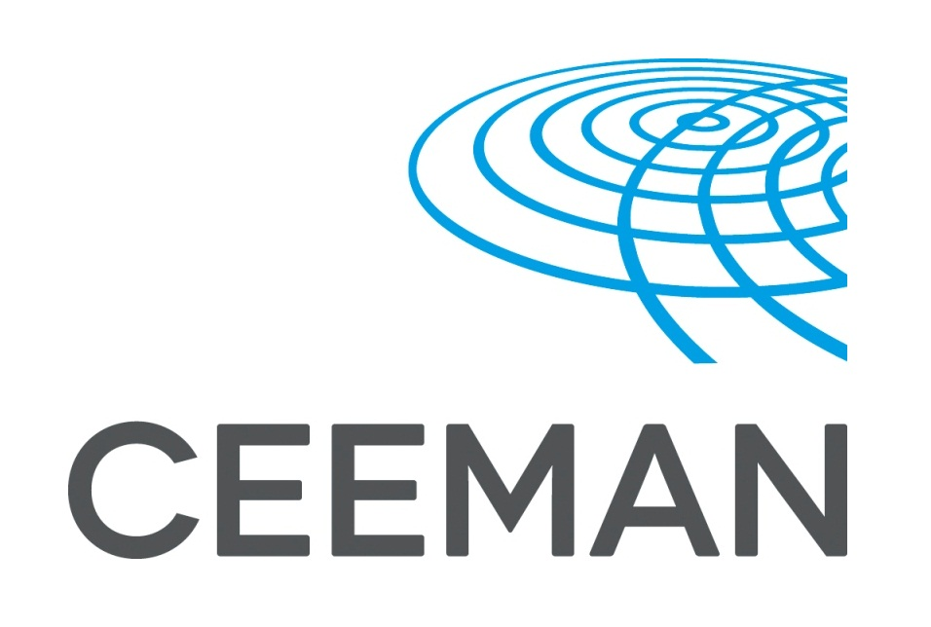


2017 CEEMAN Annual Conference in cooperation with School of Management, Zhejiang University
20-22 September, 2017

REGISTRATION FORM
Early application deadline – June 30, 2017
Please indicate your name as you wish it to appear on your name badge and the list of participants:
Name | Surname
Position |  |  | Title: Mr / Ms / Mrs / Prof / Dr
Organization
Mailing address (street, ZIP code, city, country)
Invoicing address (street, ZIP code, city, country)
(if different from above)
Phone |  | Mobile phone
E-mail |  | I would like my email address to appear on the list of participants yes no
Name of accompanying person (if any)
Accompanying persons are welcome to join conference dinners and social events, additional costs apply
I will need visa support yes no
Please send your photo (full face portrait). It will be added to participants’ list to facilitate networking.

Please mark the events that you will attend:

Company Visits, 20 September | yes | no
Poster Session , 20 September | yes | no
2017 CEEMAN Annual Conference, 21-22 September | yes | no
CEEMAN IQA Accreditation Session, 21 September | yes | no
Insights from CEEMAN Research, 22 September | yes | no
Social Events
Welcome reception, 20 September | yes | no
Gala Dinner, 22 September | yes | no
Saturday Sightseeing Tour, 23 September  Additional costs apply, to be paid on the spot | yes | no
Accompanying Persons
Accompanying person will attend the Welcome Reception on 20 September | yes | no
Accompanying person will attend the dinner on 21 September | yes | no
Accompanying person will attend the Gala Dinner on 22 September | yes | no

Food requirements I do not eat: Fish Meat Dairy products

PARTICIPATION FEES

 | Before 30 June | After 30 June
CEEMAN members | EUR 620 | EUR 750
Non-members | EUR 850 | EUR 950

*Poster session presenters are entitled to a 10% discount on the participation fee.
The fee includes attendance of the sessions, conference materials, coffee breaks, lunches and dinners (on Thursday and Friday), for 1 person as specified in the conference program, as well as transportation between the conference venues (for company visits, Gala dinner). The fee does NOT cover travel, airport shuttle, accommodation, participation of accompanying persons, or sightseeing tour. Payment of participation fee should be settled by September 10 at the latest by bank transfer upon receipt of the pro-forma invoice from CEEMAN. Unfortunately, we cannot accept credit cards.
Cancellation of participation (in writing) must be received 15 days prior to the beginning of the conference if fees are to be refunded. After that date no refunds will be made. If you are unable to attend, you are welcome to send a replacement; however, prior notification is required.

HOTEL AND TRANSFERS
Official conference hotel in Hangzhou is The Dragon hotel. We have received highly preferential conditions for the conference participants:
- Double room - standard
Price starting from 130 EUR (incl breakfast and taxes)
- Double room - superior
Price starting from 150 EUR (incl breakfast and taxes)

Please book your accommodation by 31 August 2017, as there is a certain number of rooms reserved for CEEMAN Annual Conference participants. You will receive more details regarding booking procedure after registering for the conference.

The transfer from the airport can be arranged with the hotel.

By submitting this registration form, I confirm that the information submitted is accurate and I guarantee the payment of participation fee before the event. I have taken notice of the cancellation terms.
Please contact us if you have not received registration confirmation and invoice for participation within two weeks after submitting your application form.

Date: Signature:

