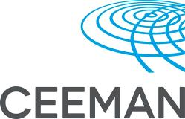

CEEMAN International Association for Management
Development in Dynamic Societies
and
Narxoz University
«Case teaching and case writing» workshop

17-20 October 2016

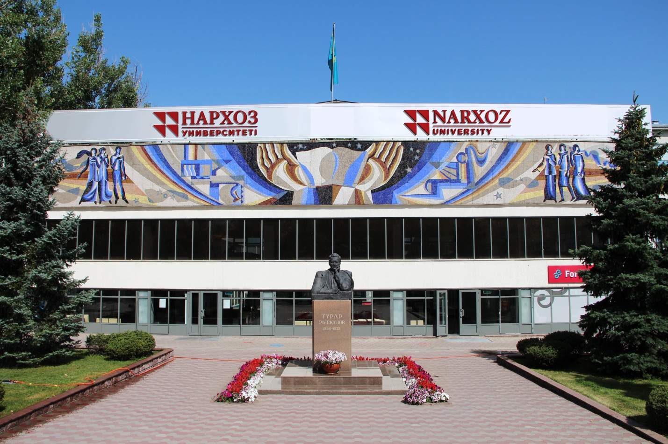

Almaty, Kazakhstan 2016

CEEMAN- International Association for Management
Development in Dynamic Societies
and
Narxoz University
«Case teaching and case writing» workshop

Date: 17-20 October 2016
Venue: Narxoz University
Participation fee:
- Early bird – before September 19, 2016 - 300 USD
- Late registration* – after September 19, 2016 – 350 USD
Language: English
Eligibility:
- Fluency in English;
- Previous experience in teaching and research in business related topics;

Scholarship: 3 scholarships will be provided by CEEMAN and Narxoz University for outstanding participants. If you want to apply for scholarship please briefly explain in statement your financial status. Shortlisted candidates will be informed by the Selection Committee.

Registration:
- Completed application form;
- Curriculum Vitae;
- Payment of registration fee;
-If you are applying for scholarship please include your statement.

Important dates:
- Early bird: before September 19, 2016 300 USD
- Registration deadline: October 10, 2016

*Applicants who does not need a visa

Preliminary programme:
Building significantly on the experience of CEEMAN – International Association for Management Development in Dynamic Societies, this 4-day workshop is designed to provide participants with good understanding of the use of case method in management education, including case teaching and case writing.

Workshop sessions:

Part 1: Case teaching:

- Teaching and learning with cases
- Pedagogical foundations of case method
- Case teaching for different audiences (undergraduate, master, executive)
- Learning with cases: individual preparation, small group discussion, class discussion
- Preparing a case for teaching
- Developing teaching plan
- Specific roles of a case teacher
- Setting the stage for fruitful case discussion
- Managing case discussion
- Evaluating learning outcomes and student performance
- Different teaching styles

Part 2: Case writing:

- Incentives and obstacles for case writing
- What makes a good case?
- General principles of qualitative case research
- Different forms of case research methodologies
- Identifying case leads
- Identifying the specific case learning objectives
- Writing a case: general guidelines and learnings from award-winning cases
- Working with co-authors
- Preparing a teaching note
- Getting your case published
- Reviewing cases written by peers

Program Faculty

Joe Pons
Dr. Joe M. Pons is the founder and President of AXIOMA Marketing Consultants, Spain, a firm specializing in strategic marketing projects as well as in the training and executive development aspects that usually go hand in hand with Customer Orientation activities. Since August 2012, Prof. Pons is a Visiting Professor at Babson College in Boston, teaching MBA and Executive Programs as well as developing new frameworks in the Entrepreneurial Marketing Mindset.
He earned his PhD at IESE, Barcelona with a doctoral dissertation on the effectiveness of marketing management practices in the branch networks of Saving Banks. For 14 years he was a Marketing Professor at IESE International Graduate School of Management in Barcelona. Currently, his regular teaching assignments include being a Visiting Professor at the IEDC-Bled School of Management. He also lectures at Instituto Internacional San Telmo in Seville, Spain and participates in seminars organized by EFMD and CEEMAN for business school academics. He has taught in more than fifty countries in institutions such as the Darden School at the University of Virginia, INSEAD in Fontainebleau (France), ESMT in Berlin and Munich, ESADE in Barcelona and IAE in Buenos Aires (Argentina).

Professor Pons is the author of a number of well-known business cases as well as articles on the use of the case method in management education. His current consulting engagements focus on aligning sales and marketing organizations to shifting strategic priorities, improving inter-functional coordination as a mechanism towards greater market orientation as well as international market selection criteria. He has worked, as consultant (among others) for Henkel, Electrolux, Deutsche Bank, Telefonica, Omnicon, ABN Amro Bank, BBVA and Bertelsmann. He has been teaching in a variety of programs and seminars at IEDC since 1997 and was awarded the 2005, 2006 and 2007 Professor of the Year award by the EMBA participants.

Prof. Jim Ellert

Jim Ellert is Emeritus Professor of Finance and Strategy, former Associate Dean of Faculty at IMD, Lausanne, and currently Co-Director of the EMBA Program at IEDC-Bled School of Management. He has more than 45 years of experience in executive education, having taught finance, accounting, economics, and statistics at the University of Western Ontario, the University of Chicago, and Queen's University, Kingston, Canada, before joining the faculty of IMD in 1981 where he extended his teaching portfolio to the areas of strategy, leadership, and marketing. He has been involved with IEDC-Bled School of Management since 1988.

Prof. Ellert’s current areas of research interest are financial management, valuation of companies, implementing value-based management strategies, financial restructuring, mergers and acquisitions, and international capital market developments. He is the author of many books, articles, presentations, and award-winning case studies on these subjects. His viewpoints and activities have been profiled in Fortune Magazine, the Wall Street Journal, Financial Times of London, Handelsblatt, International Business, Le Monde, L’Expansion, New China Post, the Staights Times, Posnovnia denevike, Koha ditore, Lider, and other managerially oriented publications.

Professor Ellert has been active as a consultant, advisor, and educator to more than 60 companies and public institutions in more than 30 countries within North and South America, Western and Eastern Europe, the Middle East, India, South Africa, the Far East, and Australia. His larger clients have included Ciba Geigy (Switzerland), Citicorp (USA), Eli Lilly (USA), EMC Corporation (USA), FIAT (Italy), General Electric (USA), Hyatt Hotels (USA), IBM (USA), Motorola (USA), Philip Morris (USA), Nestlé (Switzerland), Novartis (Switzerland), NOKIA (Finland), Philip Morris (USA), Philips (Netherlands), Pricewaterhousecoopers (USA), Royal Dutch Shell (UK and Netherlands), UBS (Switzerland), Westpac Bank (Australia), and the World Bank. He has also served on the boards of several not-for-profit organizations in Europe and North America and is currently a board member of CEEMAN and Academic Director of its IMTA – International Management Teachers Academy.

Prof. Ellert is Canadian. He graduated in political science and economics from the University of Toronto, and gained his MA in economics at the University of Western Ontario and a PhD in finance and economics from the University of Chicago.

CEEMAN – International Association for Management
Development in Dynamic Societies
Your Window to Management Development in a World in
Transition

CEEMAN is an international association for management development in dynamic societies, which was established in 1993 with the aim of accelerating the growth and quality of management development in Central and Eastern Europe. Gradually CEEMAN has become a global network of management development institutions working mainly in emerging markets and transition economies. The organization’s interests cover the quality of education, research and innovation in these economies, as well as the broad range of subjects related to change and development.

To date, CEEMAN has 215 institutional and individual members from 55 countries in Europe, North America, Africa, Latin America and Asia.

The main activities of the association include:
- International conferences
- Educational programs to strengthen teaching, research, management, and leadership capabilities in management schools
- Case writing support
- International research
- Publishing
- International quality accreditation of business schools
www.ceeman.org

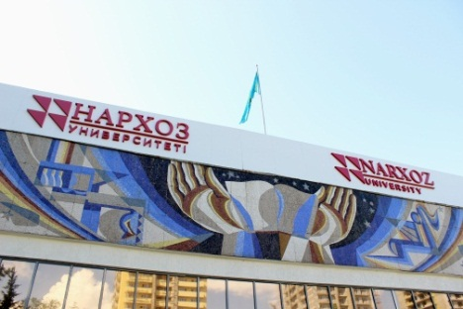
Narxoz University

Narxoz is a private university that offers education in the field of economics and business in accordance with international standards in three languages: Kazakh, Russian and English.
Founded in 1963 to provide the highest level of academic excellence in economics training prior to independence, Narxoz was one of the leading universities of the former Soviet Union with a distinguished national legacy. Narxoz today has the most famous and important alumni in Kazakhstan in business, government and entrepreneurship.
Today Narxoz University is positioned to become one of the leading innovative universities in Kazakhstan and the Central Asia region. Narxoz has embraced an unprecedented scale of reforms affecting all dimensions of the University’s curriculum, teaching methods, campus life and infrastructure in order to become a premier center of academic excellence and innovation, especially in times of economic crisis.
In 2016 Narxoz University was accredited by CEEMAN IQA (International Association for Management Development in Dynamic Societies, International Quality Accreditation) for six years.
http://narxoz.kz/

Contact for further inquiries
- Shynar Imangaliyeva
Head of International Affairs Department
shynar.imangaliyeva@narxoz.kz
Tel.: +7 727 377 12 97

- Albina Muratbekova
Head of Accreditation and Rankings Unit
albina.muratbekova@narxoz.kz
Tel.:+7 727 377 11 49

